**TEAM MEETING MINUTES**

**Team Name**: JAMBS

**Date Of Meeting**: 22 August 2017

**Start Time**: 9:30 **End Time**: 10:30

**Members Present:**

Chairperson: James Kastner 0459 514 905 james.kastner@my.jcu.edu.au

Scribe: Belle 0431 328 494 belle.belle@my.jcu.edu.au

Alicia Libera 0477 280 305 alicia.libera@my.jcu.edu.au

Scott Perry 0428 788 686 scott.perry2@my.jcu.edu.au

Michael Fisher 0410 279 722 michael.fisher2@my.jcu.edu.au

**Members Apologies**: N/A

**Meeting Chairperson**: James Kastner

**Minutes Taken By**: Belle

**Summary Of Meeting**:

***Computerisation of an Offline Workflow***

*Regional cities like Cairns and Townsville have small to medium sized businesses who struggle to fill technical roles. These roles can vary based on experience needed, hours to be worked and duration of the job. As IT@JCU has become well-known in the region many of these employers contact JCU via email or phone, asking for recommendations of suitable students and/or alumni for these roles. JCU would like to have a computerised process to:*

*(a) allow employers to post job opportunities; and*

*(b) allow IT@JCU staff to recommend students; and*

*(c) respond to employers with their CV and contact details.*

*We challenge your team to design an innovative digital workflow to solve this problem. This workflow focuses on improving the communication process between three entities: employers, staff and students.*

*Your team is not creating software. Instead, you are offering to help employers, staff and students to explore and understand future strategies that could be implemented. Next year in CP3405, you will have the chance to implement your designs from the CP2408 design challenge.*

*Target users:*

*Potential employers*

*JCU staff*

*Students.*

**AGENDA**:

1. Ratification of the meeting minutes of **Friday, 18 August 2017**
2. Follow up of action
3. Address requirements for Assessment 1
4. Michael will create proto-personas
5. Finish meeting

**AGENDA ITEMS**:

1. Minutes of the previous meeting (**Friday, 18 August 2017**) ratified.
2. Follow up action
   1. 8 ups
      1. Team members have created some 8 ups for possible MVP (Minimal Viable Product) creating visual possibilities
      2. Michael based on discussions at previous meetings has created Proto-personas
      3. Confirmed that there will be a standard fortnightly meeting to be held at the library for the team members to discuss requirements for all assessments (it is noted that due to other commitments this baseline meetings may have to adjusted)
         1. Tuesday
         2. 9:30 start
         3. 10:30 finish
         4. Library (room to be confirmed prior to each meeting)
3. Address requirements for Assessment 1
   1. Date assignment due is conflicting, James to follow up to confirm correct date.
   2. Amount of minutes to be submitted – the rubric states three (3) to be eligible for a HD (high distinction) however after a discussion with Lindsay Ward, it appears only two (2) minutes are required to achieve a meet the requirements of the rubric. James to follow up.
   3. Assessment 1
      1. 1. Describe the design challenge in your own words and specify the target users.
         1. Target users still need to be identified, to discuss at next meeting and obtain input from Lindsay Ward.
      2. 2. Preliminary research
         1. URL
         2. Insights
         3. All team members to research and provide at least two (2) results by 25 August 2017
      3. 3. Problem statement – the one created to be agreed to by all team members
      4. 4. Assumption – to be discussed at by team
      5. 5. Outcomes – to be discussed at by team
      6. 6. Proto-persona – after previous meetings, Michael created three for the team to review
      7. 7. Hypothesis statements – create three (3) to five (5)
      8. 8. Features – to be discussed by team
      9. 9. Team contact information – already provided
      10. 10. Team Collaboration Logistics – to be discussed by team
      11. 11. Project meeting schedule and objectives – to be discussed by team
      12. 12. Team meeting – need confirmation from Jason Holdsworth to see if we need to retype or can attached as PDF
4. Team to bring ‘8 Ups’ to practical Friday, 22 August 2017
   1. To be completed by Friday, 22 August 2017

**AGENDA OF 22 AUGUST 2017**

1. Apologies
2. Ratify minutes of 22 August 2017 (sign below)
3. 3.1 – James to confirm actual date of when assignment due, Friday 8 September 2017 is the date which is required to be confirmed **Friday, 25 August 2017**
4. 3.2 – James is to confirm how many minutes of meetings are required to meet the requires of a HD, to be confirmed by **Friday**, **25 August 2017**
5. 3.2.2 – Preliminary research, all team members to have minimum two (2) by **Friday**, **25 August 2017**
6. 3.3.3 – Problem statement – the one created to be agreed to by all team members by **Friday**, **25 August 2017**
7. 3.3.4 – Assumption – to be discussed by team on **Friday**, **25 August 2017**
8. 3.3.5 – Outcomes – to be discussed by team on **Friday**, **25 August 2017**
9. 3.3.6 – Proto-personas – to be discussed by team on **Friday**, **25 August 2017**
10. 3.3.7 – Hypothesis Statement – to be discussed by the team **Friday**, **25 August 2017**
11. 3.3.8 – Features – to be discussed by the team **Friday**, **25 August 2017**
12. 3.3.10 – Team Collaboration Logistics – to be confirmed by the team **Friday**, **25 August 2017**
13. 3.3.11 – Project meeting schedule and objectives by **Friday**, **25 August 2017**
14. 3.3.12 – Team meeting – need confirmation from Jason Holdsworth by **Friday**, **25 August 2017**
15. 4.1 – Create 8 ups by **Friday, 22 August 2017**
16. 6.0 – Michael will create proto-persona – **Monday**, **14 August 2017**
17. Work out suitable meeting date and time outside of practicals, that are suitable for all team members – **Friday, 18 August 2017**
18. Confirm next meeting date, **Monday, 14 August 2017**, JCU, Library Mabo Room, Room 209 (Practical).
19. James – Confirm invitation to Lindsay Ward to *Slack Channel*
20. Finish meeting **2:42 pm**

Please read minutes and advise if there needs to be any changes made before they are ratified by the team and signed off by previous and current Chairperson, this can be done at the meeting of Monday, 14 August 2017 or by sending an email to the Chairperson [james.kastner@my.jcu.edu.au](mailto:james.kastner@my.jcu.edu.au) or [belle.belle@my.jcu.edu.au](mailto:belle.belle@my.jcu.edu.au).

Please consider the Project and what you feel needs to be addressed at the next meeting, if there are any issues you would like added to the Agenda, please advise Belle by email [belle.belle@my.jcu.edu.au](mailto:belle.belle@my.jcu.edu.au) so they can be added to the Agenda prior to the 14 August 2017.

It is requested that if you are unable to attend the meeting that you notify the Chairperson by either phone or email or the *Slack Channel* as soon as possible.

Next Meeting Date: **Monday14 August 2017**

Next Meeting Time: **1:00 pm**

Next Meeting Location: **JCU Library Mabo Room, Room 209**

Current and previous Chairperson to ratify minutes of team meeting, **Friday, 11 August 2017**:

Signature: ____________________________ ____________________________

Name: James Kastner James Kastner

Current Chairperson Previous Chairperson

Date: 14 August 2017 11 August 2017

**APPENDIX A**

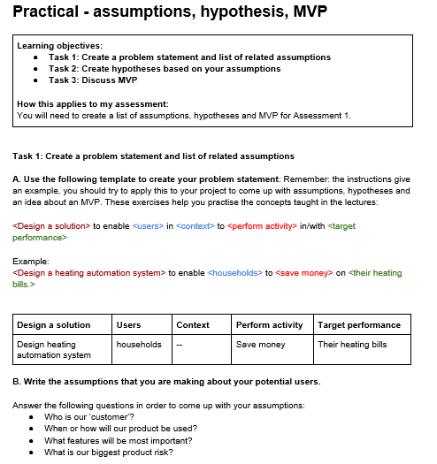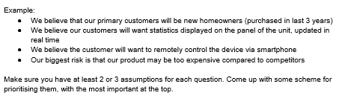

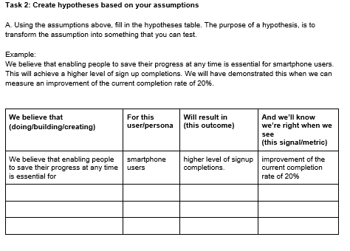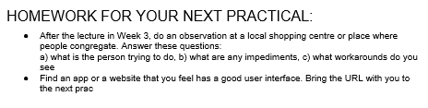

**APPENDIX B**

Problem Statement:

How might we design a product so that employers, JCU Staff and student

List of Assumptions:

* We assume that users will want to use the product
* We assume that our customers only consist of JCU staffs, alumni and employers
* We assume that employers will be aware of the product
* We assume that employers will all want the same level of access to direct contact with students
* We assume that the current methods of employment will be common practice
* We assume that users will keep up to date with employment opportunities
* We assume that people will want to tailor their CVs to specific companies
* We assume that we have all the information necessary to complete this product
* We assume that people won’t find ways to work around the current issues
* We assume that people won’t overload the message boards of employers
* We assume that employers won’t discriminate based on grade
* We assume that users will prefer to use our product over our competition’s
* We assume that the product will efficient and inexpensive for employers to use

Personas are: Students, JCU Staff, Employer

|  |  |  |  |
| --- | --- | --- | --- |
| **We believe that…** | **For this user/persona…** | **Will result in…** | **And we’ll know we’re right when we see…** |
| Creating a structured organised system for employment | JCU Student | An increased employment rate among JCU students | An increased employment rate among JCU students |
| Creating an exclusive system to promote job opportunities | JCU Students and Employers | An effective way to manage a prospective employee pool | An increase in the amount of people that sign up for the website |
| Creating a multi-platform system of employment | JCU Student | A higher interest in employment in a student’s chosen field | An increase in employment for JCU student |
| Creating a system for employment | Employers | A reduced time taken to fulfill employment opportunities | A reduction in the time needed to fulfill employment |
| Create a feature that links student’s academic results | Employers | Discrimination from employers purely based on those results | Students from all grade brackets are featured in employment |
| Creating a feature that allows employers to sort the kinds of qualifications they want for the job | Employers | Easier navigation for finding people with those qualifications | A reduced time for finding people with those qualifications |
| Create a feature that allows students to look for jobs in a specific field | Students | Easier navigation for finding jobs that they are interested in | A reduced time for finding possible jobs to apply for |
| Creating a system with possible competition | Students, JCU Staff and Employers | In a reduced use of the system | A lack of users for the system |
| Creating a system for posting employment opportunities | Employers | An inexpensive and efficient mode of searching for employment fulfillment | A low cost of managing employment proposals |

MVP

Decided to make MVP after meeting on Monday, 14 August 2017